* **Objective**

In lab 02 the concept and design of the combinational logic circuits will be covered. Purpose of this preliminary lab assignment is design a combinational logic circuit as an implementation of real life examples and for lab work in order to implement this all this scenario on digital network with VHDL language we will use BASYS3.

* **Design Specification Plan**

I designed a logic circuit for a petrochemicals companies to use in their local gas stations. I every gas station there is a bank vault in it. Only three employees; supervisor, cashier and rookie can get inside the vault. The situation of getting inside of the vault will be studied. Supervisor is the only person who has the keys of the vault which means he is the only one who has the access to the vault, if s/he is in side S is 1 otherwise it is 0. Cashier is the person who makes the daily money transfer from register to bank vault and s/he is responsible from the rookie and evaluating him/her work. If cashier is in the vault C is 1 otherwise it is 0. Rookie is training to become a cashier so s/he is observing what s/he does. If the rookie is inside the vault R is 1 otherwise it is 0. In order to design the combinational logic gate we will use two and gates, two not gates and a or gate under the sum of products method.

* **Proposed Design Methodology**

Only the supervisor has access the bank vault so if someone else wants to get in the vault they must be together with the supervisor. Also rookie always has to be with the cashier in order to be monitored. If rookie is in the vault cashier must be in the vault as well as the supervisor.

Truth Table

|  |  |  |  |  |
| --- | --- | --- | --- | --- |
| S | C | R | H(S,C,R) | Minterms |
| 0 | 0 | 0 | 0 | $$m_{0}$$ |
| 0 | 0 | 1 | 0 | $$m_{1}$$ |
| 0 | 1 | 0 | 0 | $$m_{2}$$ |
| 0 | 1 | 1 | 0 | $$m_{3}$$ |
| 1 | 0 | 0 | 1 | $$m_{4}$$ |
| 1 | 0 | 1 | 0 | $$m_{5}$$ |
| 1 | 1 | 0 | 1 | $$m_{6}$$ |
| 1 | 1 | 1 | 1 | $$m_{7}$$ |

Sum of possible scenarios( minterms) $=\sum_{ }^{ }{m\left(4,6,7\right)=}m_{4}+m_{6}+m_{7}=H(S,C,R)$

$$H\left(S,C,R\right)=S.\overline{C.}\overline{R}+S.C.\overline{R}+S.C.R$$

$$=S.\overline{C.}\overline{R}+S.C.(\overline{R}+R)$$

$$=S.\overline{C.}\overline{R}+S.C$$

$$=S.(\overline{C.}\overline{R}+C)$$

$$H\left(S,C,R\right)=S.(\overline{C.}\overline{R}+C)$$

**Logic Schematic Diagram**

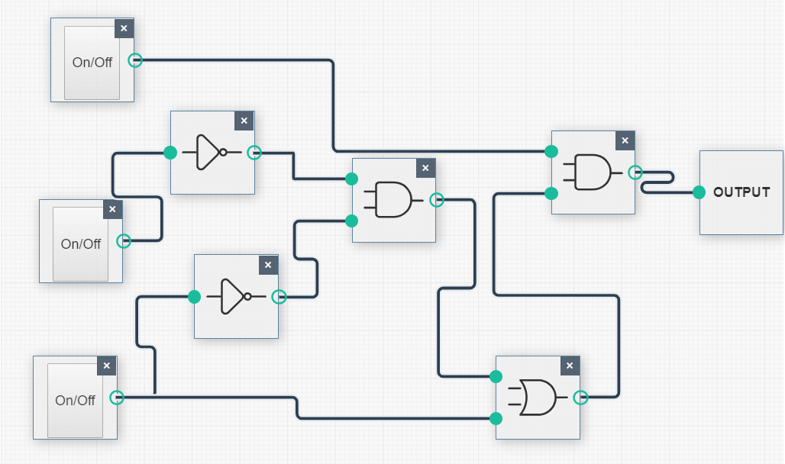

R

Not2

Not1

Or1

H

And2

And1

S

C